IQAC LOGO College Logo College Logo Whitecode logo

www.[iqacclusterindia.com](https://iqacclusterindia.com/) www.whitecode.co.in

***IQAC Cluster India and White Code Technology Solutions Pvt. Ltd.***

*in Association with*

***Shri Jagadamba Vinkar Shikshan Sanstha Achalpur's***

***Jagadamba Mahavidyalaya, Achalpur City***

***And***

***Atul Vidya Mandir Wardha’s***

***Rajarshee Shahu Science College, Chandur Rly***

*Organized Three Days National Level webinar*

*on*

***“Conquering less attended areas in NAAC & Outcome based Education”***

*CERTIFICATE OF PARTICIPATION*

This is to certify that Dr./Mr./ Ms. _____**Sandip Nanaware**________________ from___**_*XYZ College***__________________________ has participated in the 03 days National Level Webinar On Conquering Less Attended Areas In NAAC & Outcome Based Education. Organized By IQAC Cluster India And White Code Technology Solutions Pvt. Ltd. In Association With Shri Jagadamba Vinkar Shikshan Sanstha Achalpur's Jagadamba Mahavidyalaya, Achalpur City And Atul Vidya Mandir Wardha’s Rajarshee Shahu Science College, Chandur Rly. on 1st June 2020 to 3rd june 2020 for 12 hours.

Signatures:-

Mr. Amit Patil Prof. Peeyush Pahade Dr. P. G. Rohankar Dr.S.S.Thakare

(CEO WhiteCode) (Co- Founder, IQAC (Principal,Jagadamba (Principal, Rajarshee

Cluster India) Mahavidyalaya Achalpur City ) Shahu Science College)

College Logo:

1. Jagadamba Mahavidyalaya Achalpur City

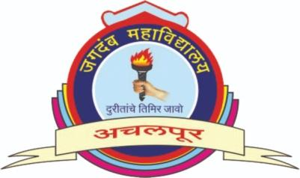

1. Rajarshee Shahu Science College,Chandur Railway Dist. Amravati



Signatures:

1. Dr. P. G. Rohankar



1. **Principal Dr.S.S.Thakare**

